** **

**A.P.C. MAHALAXMI COLLEGE FOR WOMEN**

**Reaccredited by NAAC with ‘B+’ grade**

**Thoothukudi - 628 002**

**CONSOLIDATED REPORT 2019-2020**

**Library Advisory Committee**

**A.P.C. MAHALAXMI COLLEGE FOR WOMEN, THOOTHUKUDI**

**LIBRARY ADVISORY COMMITTEE**

**2019-2020**

Freshers Orientation Programme was organized by Library Advisory Committee of A.P.C. Mahalaxmi College for Women on 02.08.2019 at 10.30 am at the premises of Auditorium, A.P.C. Mahalaxmi College for Women, Thoothukudi. The major objective of this programme was to make the students to understand the importance of library, digital library and rules and regulations of the library.

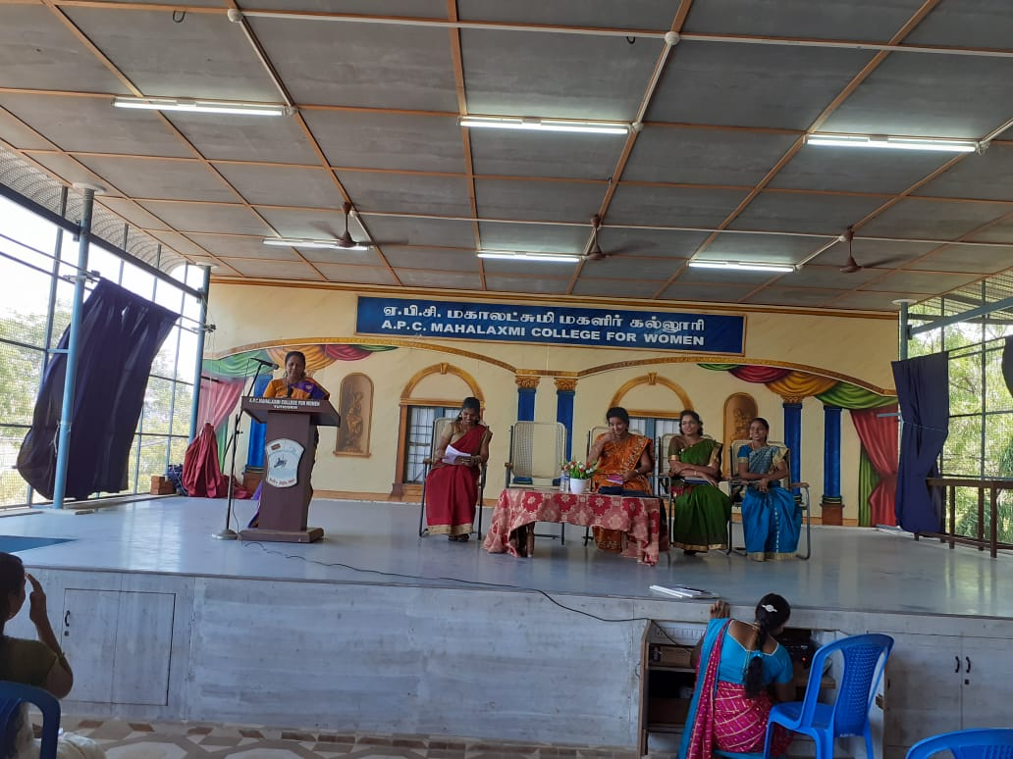

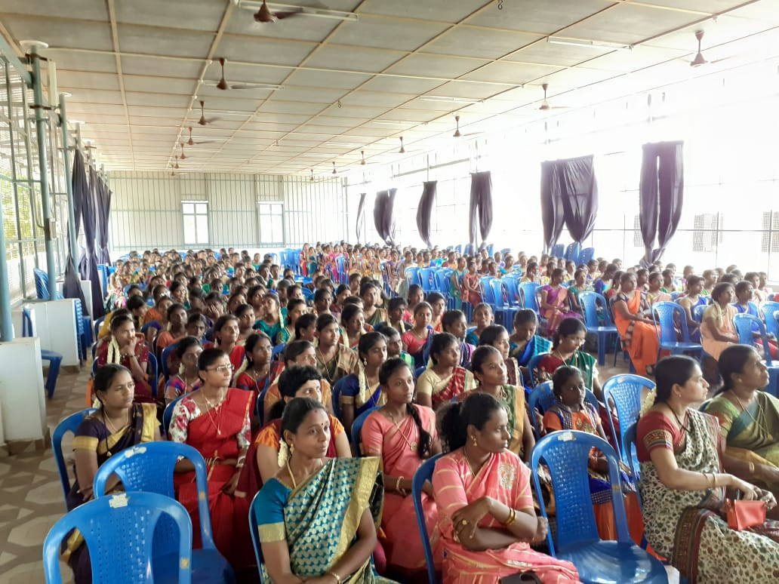

Read A Book Day was organized on 06.09.2019 at 2.30 pm at the premises of A.P.C. Mahalaxmi College for Women, Thoothukudi. The major objective of this programme was to make the students to understand the importance of reading and motivate them to improve their reading skills.

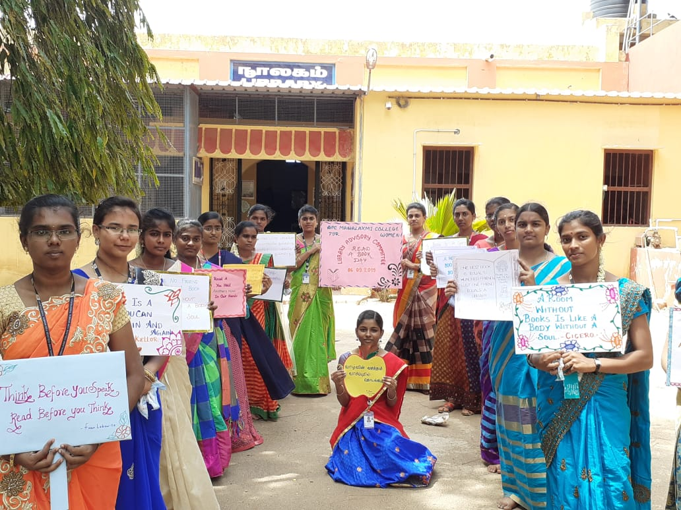

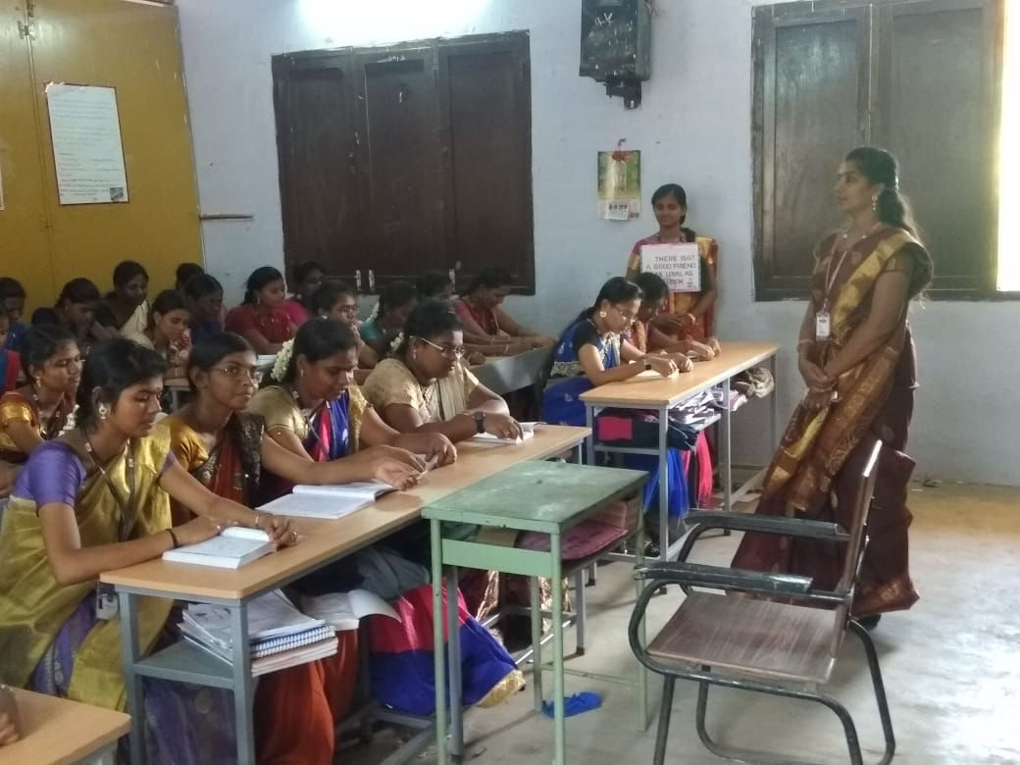

Under the ageis of the IQAC, The EXCEL Club and the Library Advisory Committee of A.P.C. Mahalaxmi College for Women, Thoothukudi, Tamilnadu, organized a self-paced Online Course on “The Wonderful World of Wizarding ”, a registered international digital event under Bloomsburry Publishing in association with the International Youth Society, Tuticorin Chapter in quadragennial commemoration of the fictional character Harry Potter on 31.07.2020.The course was offered free of cost by the Excel Club and the Library Advisory Committee for 500 participants on first come, first served basis. The course was taken by various national participants and a few international participants and the course completion certificate was mailed to the participants based on their learning outcome. The course ensured that the participants came to know all about J.K. Rowling and her Harry Potter series and kindled their interest to read books.

